Template – measuring the impact of science communication projects

Target group: children
Version 4.0 (last edited 12/2022)

This template can be used to measure the impact of your science communication projects. Throughout the document, you will find instructions and background information in these yellow boxes.

You can add, remove and adjust elements to ensure that the instrument fits your goal, target group and measurement tool. Keep in mind that you will have to use the same questions consistently if you want to make comparisons between impact measurements.

Step-by-step guide

1. Complete the information between [these brackets].
2. Delete the yellow boxes on each page.
3. Read the entire document from the perspective of your audience. Check whether the elements form a coherent whole and whether they fit your target audience and project.

Background information on certain items and constructs can be found in our accompanying paper (currently only in Dutch). You can visit our website for additional tools and more information about measuring impact.

If you have any questions, remarks or would like to receive some advice, feel free to get in touch!

Consent

Always explicitly ask your participants for their consent to collect and process their data. Keep it short and simple, but at least include:

- The name of your institution/company and
contact information of the head researcher.
- The purpose of the study.
- Whether data will be used for purposes
other than the evaluation of your project.
- The rights of the participant.

If you measure impact among children, be aware that you need to inform a parent or custodian and ask for their permission. If applicable, ask the ethical committee of your institution/company to review your plans.

Before we begin, ask a parent or custodian to read the following text.

- This study is conducted by [name institution/company]. If you have any questions about this study, you can get in touch with [name], [e-mail address].
- To participate, permission from a parent or custodian is needed.
- The answers collected in this study will be used for the evaluation of [name of event]. The answers will not be used for other purposes, nor be shared with third parties.
- The answers collected in this study are completely anonymous.
- Participating is completely voluntary. The participant can stop at any time.

I declare that I have read and understood the information mentioned above and give the researchers permission to store, analyse and report the anonymised results.

▢ Yes ▢ No

1. Demographics

This section includes questions on some general characteristics of your audience, such as their age, education and residence. These questions allow you to examine whom you have reached with your project.

If primary school children are your target audience, it is often sufficient to only collect data on age and gender. If you measure among older children, you can also include questions about schooling and residence.

How old are you?

I am a | ▢ Boy ▢ Girl ▢ Other

Additional questions:

What type of schooling are you currently enrolled in? | [Add relevant educational levels as answering options. You can use the options below for Dutch students].  ▢ vmbo ▢ havo ▢ vwo ▢ mbo
 | Other:

What is your postal code/zip code?

2. Science Capital
In this section, you assess the science capital of your audience. The concept of science capital can be used to measure how familiar someone is with science: to what extent does science play a part in their daily lives? Again, these questions allow you to examine whom you have reached with your project.

We want to ask you some questions about science. Science is about research, asking questions, being curious, looking for solutions, experimenting and discovering new things. It can be about almost anything, such as nature, space, people, language and [the theme of your project].

We would like to know what you think about science. It is all about your opinion, there are no right or wrong answers!

Read the sentence and choose the smiley that best fits your opinion.

Answering example:

Fully disagree Fully agree

I know something about science.
I like learning about science.
In my spare time, I sometimes engage in activities where I learn something about science, such as visiting a museum, looking up information online or watching television or videos about science.
I know people who work with science in their job.

3. Emotional Memory
In this section, you map the emotional response of your audience. Two elements of emotions play an important role in predicting how well projects and their messages will be remembered: enjoyment and intensity. When your audience experiences positive and intense emotions, your project is more likely to create long-term impact.

When you think about [name project], how do you feel?
Choose the circle that best fits your feelings.

Answering example:

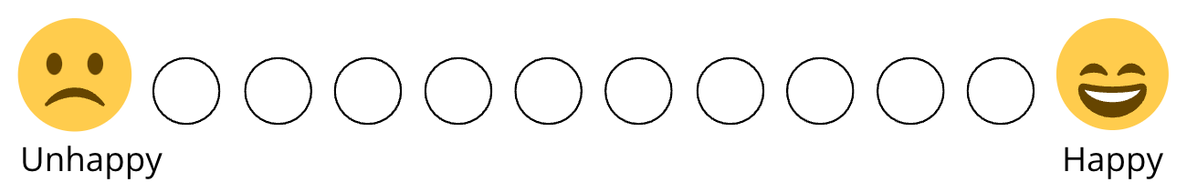
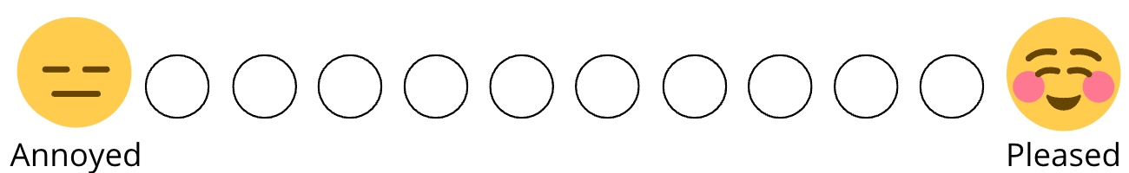
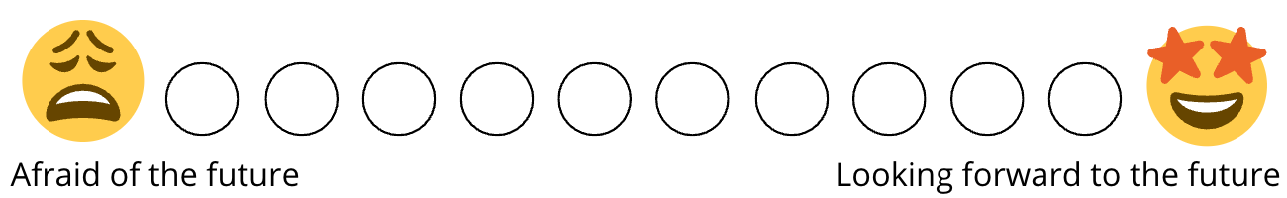
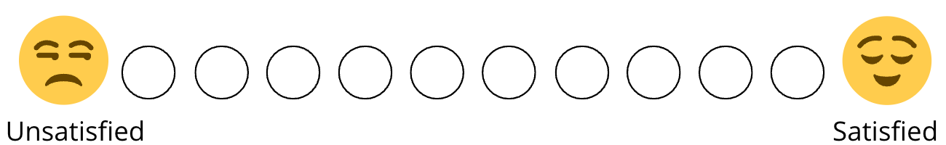

This section continues on the next page. Feel free to put the two columns on one page in your own measurement.

Which words describe your feelings about [name project] best?

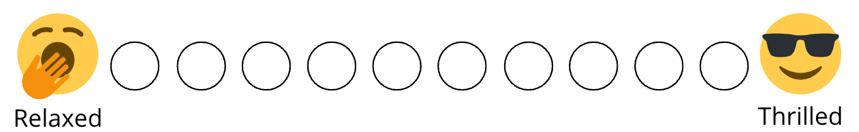
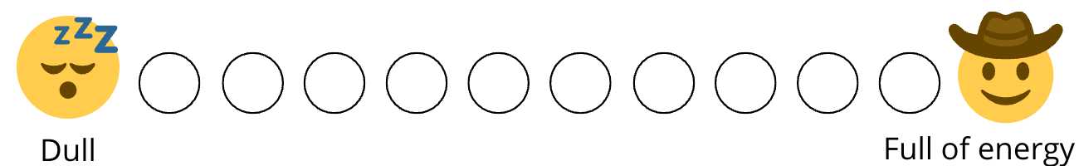
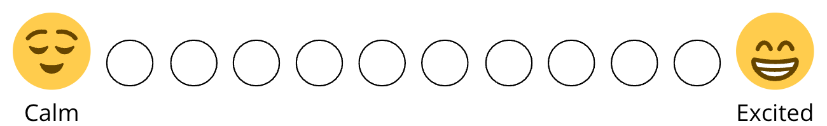
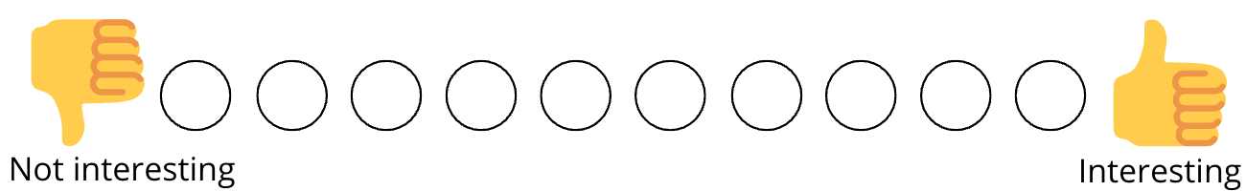

Will you measure impact digitally and would you like to use the questions as formatted above? You can download the original files here.

4. Effect-analysis
In the last section, you assess whether your project was able to affect the knowledge and attitude of your audience. In addition, you also test whether your project has sparked the audience’s interest in learning more about the topic of your project and whether they would be interested in engaging in similar activities in the future.

Read the sentence and choose the smiley that best fits your opinion.

Answering example:

Fully disagree Fully agree

I learned a lot about [topic of project].
I now want to learn more about [topic of project].
I now think differently about [topic of project].
After [name of project], I would like to do similar activities in the future.

The third question in this section measures whether your audience’s attitude has changed. If you want to know in which direction your audience’s attitude has changed, you can replace this question with the following multiple-choice question:

Do you like or dislike [subject of project] more after [name of project]?

▢ I like [subject] a lot more now 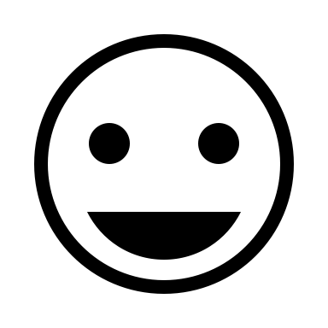
▢ I like [subject] a little more now 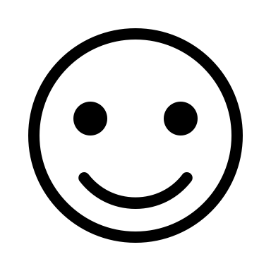
▢ I feel the same way about [subject] as before.
▢ I dislike [subject] a little more now 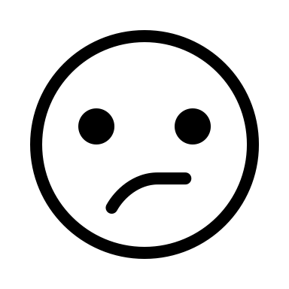
▢ I dislike [subject] a lot more now 