Worksheet Impactplan
Goal - which of these communication goals do you want to measure?
Knowledge | Behaviour | Awareness
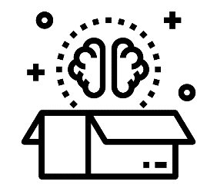 | 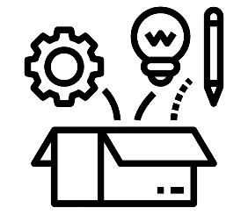 | 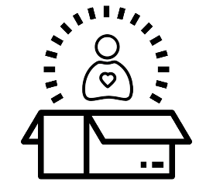

Inform  Teach  Educate  Train  Coach | Inspire  Motivate  Convince  Spark creativity  Empower  Enable | Create new experiences  Create new insights  Create perspective  Improve understanding  Improve attitudes

Jot down some ideas on how to measure this goal. What are some specific aspects you want to focus on?

Type of data - will you collect trace data or response data?

Trace data | Response data
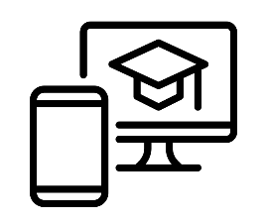 | 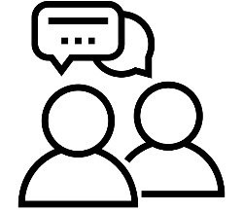

Specify the type of data you want to collect and why you want to collect it:

Target group - who are you designing the instrument for?
Younger than 12 y.o. | Between 12 and 18 y.o. | Between 19 and 35 y.o. | Between 36 and 65 y.o. | Older than  65 y.o.
 | 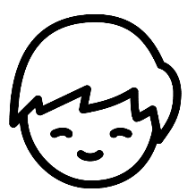 | 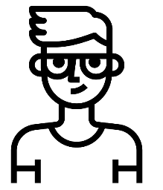 |  | 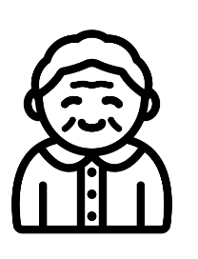

Think about your target group for a bit longer. Which interests or needs characterise this group? How do these characteristics influence the method and design of your measurement?

In what way do you want your target group to participate in the impact measurement?
Providing information | Exchanging ideas | Participating creatively
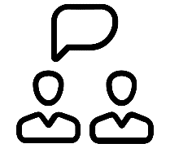 | 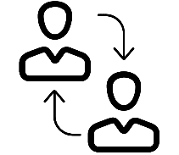 | 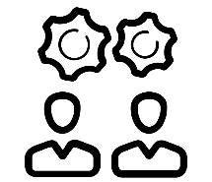

Describe the way your target group can participate. Think about what that means for the set-up of your impact measurement.

How many people will participate in the impact measurement during the activity or event?
0-25 | 26-100 | 100+

Estimate the number of participants. Think about what that means for the set-up of your impact measurement.

Next steps
By completing this worksheet, you made the first few steps towards designing your own impact measurement. To develop your impact measurement further, you can consult the information and tools on our website (https://impactlab.sites.uu.nl/en). A logical next step could for instance be to complete the decision tree, which filters all the measuring methods of our toolbox.

