Analysing and reporting an impact measurement
A manual from IMPACTLAB.
Version 1.0. Last updated April 2023.

Table of content

1. Introduction
2. Data analysis - quantitative
2.1. Preparing data
2.2 Analyse data
2.3 Interpretation and reporting
2.4 Making comparisons
3. Qualitative data analysis
3.1 Preparing data
3.2 Analyse data
3.2.1 Coding
3.2.2 Open questions
3.2.3 Interviews
Define codes
3.3 Interpretation and reporting
4. Setting improvement goals

1. Introduction
This guide offers a step-by-step explanation on how to analyse the data collected from an impact measurement. The guide focuses on simple and easy-to-perform analyses, as these are often sufficient to identify the achieved goals and target groups of a scicom activity.
The guide is divided into three parts: analysing quantitative data, analysing qualitative data and setting improvement goals. This last section is relevant to both types of analyses and is the final step of analysing your impact measurement.
In this guide, we distinguish between analysing quantitative and qualitative data. If you are not sure whether you are dealing with quantitative or qualitative data, please refer to the box below.
Want to know more about measuring impact, use our materials or ask us a question? Then take a look at our website.
Tip: turn on the document overview so you can easily navigate between the sections of the manual. In Word, you can turn on this overview via View, Navigation pane. In Google Docs, open the navigation pane via the square in the top left corner.
Qualitative and quantitative
How you analyse your impact measurement data depends on the type of data you collected: quantitative or qualitative.
Quantitative data can be expressed in numbers, tables and graphs. These data answer questions such as:
- What percentage of visitors learnt something new about the topic?
- On a scale of 1 to 10, how exciting did the average visitor find the scicom activity?
- What is the average age of visitors?
You are dealing with quantitative data if, for example, you counted visitor numbers or presented your audience with close-ended questions, such as those from the question bank.
Qualitative data deals with words and meanings and is used to identify concepts, thoughts and experiences. You are dealing with qualitative data if, for example, you have used interviews, dialogues or open-ended questions.
It is not unusual to collect both types of data during an impact measurement. In this case, you perform both quantitative and qualitative analysis.

2. Data analysis - quantitative

2.1. Preparing data
In this example, we will use Google Sheets. This programme is free to use and works through your browser. All you need is a Google account. The exercise file we will use in this section can be downloaded here. You can import the exercise file into Google Sheets via File, Open and then Upload.
To get started, first gather all the data into one digital file.
Online questionnaire
If your measurement was done using an online questionnaire, you can export the data to a file format of your choice. For Google Sheets, for example, this is .xslx (you can also use this if you want to work with Excel) or .csv (you can also use this if you want to work with R). To import your dataset into Google Sheets, first click File, Open and then Upload.
It is a good idea to save a copy of the original dataset first. Click on File and then Create copy. You can call this copy "Raw data", for example.
Return to the dataset you just made a copy of. In the columns (A-Z) you will find the labels of the variables, in each row (1-1000+) the completed answers per participant. Check for yourself whether the labels of the columns are recognisable and adjust them if necessary. The label "Q2: How old are you?", for example, could become "Age".
Feel free to remove or hide unnecessary columns from your dataset, such as date, time or participants' IP address. To keep your dataset well-structured, you can even choose to keep only those columns that represent the questions in your questionnaire. Take a look at the exercise file to see which columns these are for the question bank.

Paper questionnaire
Did your measurement use paper questionnaires? Then you first enter the data in a digital file. You can use the following steps for entering data:
- Create a new file in Google Sheets (or a programme of your choice).
- In the columns (A-Z) write down the questions from the questionnaire. A short description or abbreviation is sufficient. For example, we use "SciCap1" in the exercise file for the first question measuring science capital.
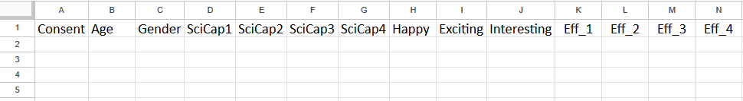
- Look at the first completed questionnaire and enter the participant's answer under each column. Note: each row represents one participant. Thus, you always enter the answers of one questionnaire in one row.
For open-ended and multiple-choice questions, you can enter the full text. For scales, it is easier to give each answer a mark. For example:

“I like learning about science”
Totally disagree ◯ ◯ ◯ ⬤ ◯ Totally agree

Enter: “4” for “SciCap2”

“Choose the circle that best fits how you feel”
Boring ◯ ◯ ◯ ◯ ◯ ◯ ◯ ⬤ ◯ ◯ Exciting

Enter: “8” for “exciting”

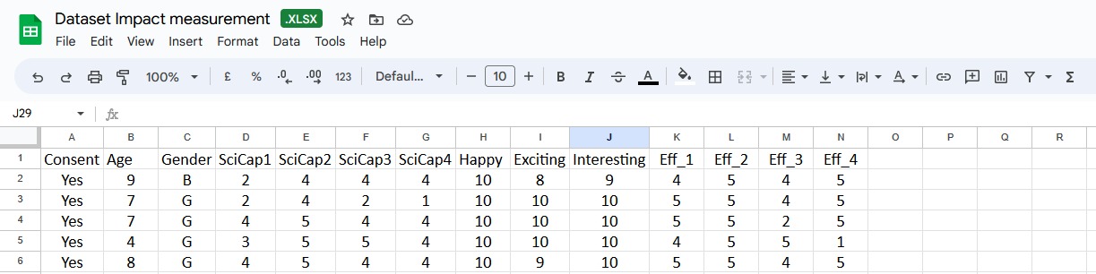
- Enter all answers in this way until all questionnaires are processed.

Data scanning
Before you start analysing, check whether your data contains missing or anomalous information.
- Missing information
  - These are empty cells. A few empty cells per participant are not a problem, but pay attention to participants who filled in very few questions. Ask yourself whether these participants' answers are useful and reliable and then decide whether to include their data in the analysis.
- Divergent information, such as:
  - Answers not matching the requested information.
    - Like the answer "x" for age. In this case, you can choose to leave the cell blank to make sure the age for this respondent is seen as missing data.
  - Participants falling outside your target audience.
    - Ask yourself whether the information from these participants could be relevant to your measurement and then decide whether to include the data in your analysis. For example, for a measurement among children, you could say that data from participants aged 15 or older are not relevant.
Whatever choices you make, explain them and be transparent.

2.2 Analyse data
For the quantitative data you have collected, you can calculate the mean, visualise the frequencies and create a graph. Among other things, this can give you answers to the questions:
- What is the average age of my audience?
- What percentage of participants learnt something new?
- How high is the science capital of my audience?

2.2.1 Average
The average can be calculated by Google Sheets and appears at the bottom of the column of the corresponding question. To avoid confusion, you can first clarify for yourself which numbers are the averages, for example by colouring the row in which the averages appear. First select the whole row by clicking on the row's number on the left, and then choose a colour via the Fill Colour button.
Choose the question of which you want to calculate the average and find the corresponding column in Google Sheets. Click on the first answer in the column (just below the column name) and then find the last answer in the column. Hold shift on your keyboard while clicking the last digit in the column to select all the numbers in the column.
When you have selected all the numbers in a column, click Insert. Click Function and choose the AVERAGE option and press enter. The average will now appear at the bottom of the column.
You can now copy this function to the other questions in your dataset. To do this, select the column with the average and move your mouse to the bottom-right corner of the cell. Hold down the left mouse button as your mouse turns into a plus sign. Drag the mouse to the right and release at the last filled in column in your dataset.
If desired, you can use the buttons under Insert to adjust the number of decimal places. For question bank questions, we recommend rounding off to two decimals. For age, however, it is fine to round the average to a whole number.

2.2.2 Frequencies
The disadvantage of the average is that it gives no insight into the spread of the answers: you don't know how often each answer was chosen. Calculating Frequencies does allow you to see this. In this example, you learn how to calculate frequencies, how to convert frequencies into percentages and how to make a graph.
NB: You can also calculate frequencies for questions like "gender," whose answers are not numbers.

Why is just an average not reliable?
Imagine: you have used a scale from 1 to 10 that measures how interesting participants find your audience activity. The average of the question is 5, because the majority of participants chose 4, 5 or 6 as their answer. As a result, you can conclude: most participants found it somewhat interesting.
Now imagine the average is 5, because half the participants chose the option "1 - not interesting" and the other half "10 - interesting." You cannot now say, based on the average of 5, that most people found it somewhat interesting. Half found it interesting and the other half did not.

Preparing data
Choose the question whose frequencies you want to calculate and find the appropriate column in your data file. Select the answers including the name of the column (without the mean) and copy your selection. Create a new tab by pressing + at the bottom left and paste the copied cells into this new tab.
You will use this new tab to calculate frequency and percentages. To keep the tab well-structured, it is useful to make a note of which values will end up in the tab. To do this, type Answer, Frequency and Percentage in the three columns next to your question.

Defining unique response options
Before you calculate frequencies, let Google Sheets first determine which answer options occur in your data. This is especially useful in larger datasets or if there are many different answers in your dataset.
Select the cell under Answer (B2) and choose Insert, Function, Filter, UNIQUE. After selecting the function, Google Sheets asks you which data you want to know the unique values of. Click the top value of your query in Column A (A2) and hold shift while clicking the last value (In the example, A21). Then go into the formula box in the top left of your screen and enter a $ sign between the A and the number (in the example, this gets you =UNIQUE(A$2:A$21)). Then press enter.
Under Answer you will now see all the unique answers that occur in your chosen question. In the example, these are answers 2 to 5. However, the SciCap1 scale runs from 1 to 5, so we also want to see the "1" option in the Answer column. To do this, right-click on the first cell under Answer, choose Insert Cells, Insert Cells and shift down. Type "1" in the empty cell that appears.
Tip: make sure you include all available answer options in your analysis, including those not chosen by participants. You can enter these manually.

Calculate frequencies
To calculate how often each answer option appears in your data, select the first cell under Frequency (C2). Choose Insert, Function, Array, FREQUENCY.
The function asks you for data and classes. The data are all the answers listed under Column A. Click the top value and hold shift while clicking the last value. To put the classes in the function, first press ; on your keyboard. The classes are the possible answer options you calculated in the previous step. Click the top value under Answer (B2) and hold down shift while clicking the last value. Press enter.
You can now see how often each value appears in the Answer column on the right in the Frequency column. In the example, the answer "2" occurs five times, the answer "3", three times, etc. The "0" at the very bottom indicates that there are no answers outside the indicated answer options. In other words, all the answers given fall between 2 and 5.
2.2.3 Relative frequency (percentages)
Now that you know how often each answer option occurs, you can easily calculate the relative frequency: how often each answer option occurs relative to the other answer options. To calculate this percentage, divide the numbers under Frequency by the total number of answers given.
You can find the total number of answers given by adding up the values under Frequency. In the Frequency column, select the cell under the second "0" and click Insert, Function, SUM. Select all the values in column C and press enter.

The number that now appears below the zero is the total number of answers given (20 in the example).
Now divide the numbers under Frequency by the total number of answers given. To do this, select the top cell under Percentage (D2) and type in the following:
=C2/X
In the place of "X" write down the total number of answers you calculated in the previous step. In the example, this is 20. You then type: =C2/20 and press enter.
Complete the rest of the percentages automatically by standing in the bottom right corner of D2 and dragging the black cross that appears down. Select all calculated values that remain and click Format as percentage. If desired, you can round the percentages to whole numbers.

2.2.4 Creating a graph
Using this template, you can now easily create a graph in a few steps.
- Always first make a copy of the template before working in the file. Click File and then Make Copy. Close the original file.
- If necessary, change the answer options under Answers. We have chosen text in the template (matching the question from the question bank), but you can also enter values here (e.g. 1 to 10, as for emotional memory). You can copy the answer options from your dataset and paste them into the template.
- Copy the percentages from your dataset and paste them into the template under Percentages. If you calculated the percentages via a formula, after pasting the values, click on the clipboard that appears at the bottom right. Choose Paste values only and the percentages will appear.
- Check again that the correct percentages are now next to the correct answer options.
- Double click on the graph.
  - Click on the title to change it. Replace "Question" with the question text or with an appropriate description, e.g. "I know a bit about science," or "Age."
  - After the question text or description, (N=X) appears in the title. The N stands for the sample size: the number of participants in your measurement. Replace the "X" with this number (20 in the example).
  - Now click on "Average score" in the text and substitute "X" for the average score of the question. You can find the average in your dataset on the first tab.
- To download the graph, click on the three dots in the right-hand corner of the graph. Click Download and choose the desired file format.
- To create another graph, click the triangle next to the first tab and choose Duplicate. Repeat the steps above from step 2.
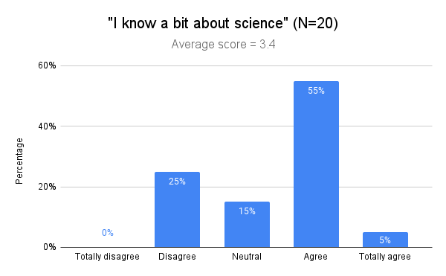

2.3 Interpretation and reporting
What can you say about your audience activity from the calculated averages and frequencies?
Drawing conclusions
- Use the graphs you created in the previous steps to see how participants score for each question.
- If you have used questions that have an overarching theme or measure one element together, hold them side by side to see where they match and differ.
  - You can also calculate an overall score for these questions by adding up the average scores. For the questions from the basic instrument, however, we recommend analysing each element separately.
- Think about what you want to use the data for. For instance, is it just to evaluate your project or do you also want to go public with your results? Use your plans and sample size (see box below) to make the necessary nuances.

Sample size
- The more people participated in your impact measurement, the more reliable the results will be. For an impact measurement, you can say that the data is reasonably reliable from 50 participants onwards.
- When sharing your results, always mention the sample (N) and avoid drawing sweeping conclusions if your sample is small. For example, say "70% of impact measurement participants (N=20) reported having learnt something new," rather than "70% of all participants learnt something new.").

2.3.1 The scope of your audience activity
Once you have collected demographic data (e.g. age, place of residence and education), you can map out what kind of audience came to your activity. This will also allow you to test whether this audience corresponds to the target group you had in mind.
Example: you wanted to reach children between the ages of 6 and 12 who do not yet know much about science. You collected the following data on the age of the participants:
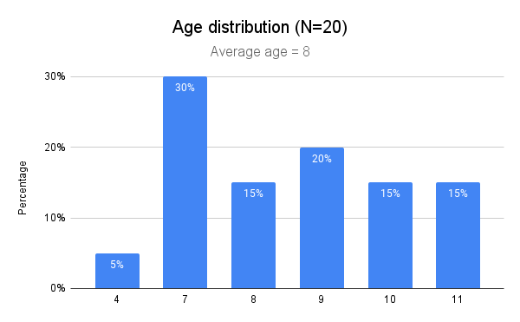
Most participants are between 7 and 11 years old, so in terms of age, you can conclude that you have reached the right target group.
To test children's knowledge regarding science, you collected the following data:

- The mean is 3.40, which is slightly above the midpoint (3) of the scale. On average, participants scored neutral-positive on this question.
- The graph shows that the majority of children (60%) says they do know something about science. A quarter (25%) says they do not know much about science and 15% is neutral.
- Reporting: "Knowledge about science among impact measurement participants (N=20) is somewhat scattered. The majority (60%) of participants said they did know something about science, while a quarter (25%) said they knew little about science. The target group "children who know little about science" was reached to a reasonable extent (25%)."
2.3.2 The impact of your audience activity
Besides scope, you may have used questions in your measurement that tell you something about the effect of your audience activity. In this example, we use two effect questions from the question bank (Eff_1 and Eff_3 from the exercise file).
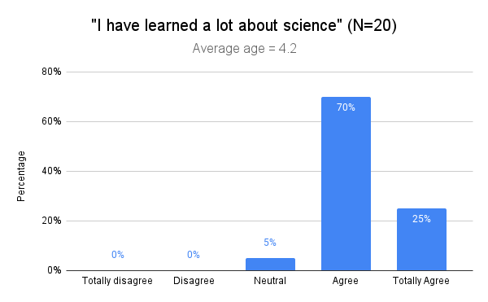

- This question visualises whether there have been any changes in participants' knowledge. The mean (4.20) is well above the midpoint (3) of the scale: on average, participants score positively on this question. This is also reflected in the percentages: 95% of the children report having learnt something.
- Reporting: "Almost all participants of the impact measurement (N=20) reported having learnt something (95%). This indicates the scicom activity potentially had a positive impact on participants' knowledge."
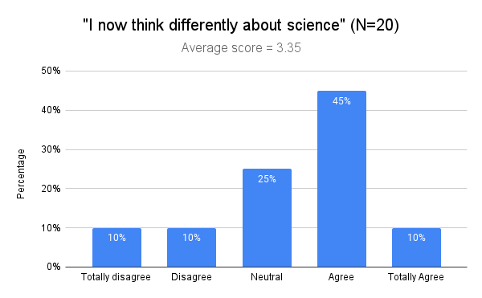
- This question charts whether there has been any change in participants' attitudes. The mean (3.35) is above the midpoint (3) of the scale: on average, participants scored neutral-positive on this question.
- The graph shows some division. The majority of participants say they now think differently about science (55%), a quarter (25%) are neutral on the question and 20% say they do not think differently about science.
- Reporting: "Not all impact measurement participants (N=20) indicated that they now think differently about science: 55% now thinks differently about science, 20% don’t think differently and a quarter (25%) is neutral on the question."

Overarching conclusion
After analysing all the questions separately, you can write a short conclusion for each related element. Try to make a brief and concise comparison between the different elements you measured. For example, for the two questions above, you could conclude:
"The scicom activity potentially had a positive effect on participants' knowledge: almost all participants in the impact measurement (N=20) reported having learnt something about science (95%). The effect of the audience activity on participants' attitudes is more divided: only 55% of participants indicated that they now think differently about science."

2.4 Making comparisons
When you have conducted multiple impact measurements or used a pre- and post-measurement, you can compare the results of these measurements. For quantitative data, you can do this by comparing both averages and relative frequencies.
To make reliable comparisons, it is important that the two samples match as much as possible: both in personal characteristics (such as age and gender) and sample size (the N). The greater the differences in the two samples, the more likely these differences will also affect the impact measurement results. Therefore, when comparing measurements, present not only the impacts but also, for example, the age and gender distribution of both measurements. To keep the manual concise, we only demonstrate an impact comparison here.

To illustrate the comparison of measurements, we use a fictitious example of an audience activity on reading. Two measurements were taken: one before the event and one after. The statement "Reading is fun," was used to measure whether the audience activity had an effect on participants' attitudes. The responses to the statement are as follows:
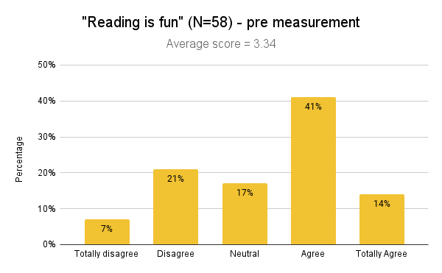
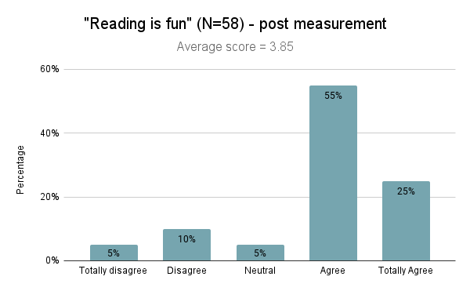

Compare average
The first thing you can do is compare the mean scores. In the first edition, the mean is 3.34, in the second edition 3.85. To calculate how much the average has increased or decreased in percentage terms, you can use the following formula:
$$\frac{New average - Old average}{Old average} x 100\%$$

If the mean has increased, the outcome of this formula is positive. In the example, the formula yields the outcome 15.3%: the mean increased by 15.3% in the second edition compared to the first edition.
If the mean has decreased, the outcome of the formula is negative. For example, if a mean has changed from 4.20 in the first measurement to 3.85 in the second measurement, this produces the outcome -8.3% in the formula. You can then say the mean has decreased by 8.3%.
When calculating this kind of difference score, always determine for yourself what the meaning of the difference is. Avoid drawing sweeping conclusions when the differences are on the small side.
Compare spreads
For a complete picture, it is also important to compare the spread of scores between the two measurements. This will also give you insight into the "why" behind the change: for example, are the scores higher because participants answered neutral more often instead of negative, or is there also an increase in positive answers? You can compare the percentages of the same answer options to answer this question.
If you look at the two graphs from the example, for example, you can see that especially the answers "Disagree" and "Neutral" decreased. "Disagree" was answered 11% less often and "Neutral" 12%. Responses to "Agree" increased the most, by 14%. The stronger "Totally agree" also increased by 11%.
Reporting
"Attitudes towards reading were more positive in the second edition (mean 3.85, N = 60) than in the first edition (mean 3.34, N = 58). This increase of 15.3% may indicate that the second edition of the audience activity had a greater effect on participants' attitudes than the first edition. The distribution shows participants in the second edition responded less often negatively and neutrally and more often positively and strongly positively. Thus, the adjustments made in the second edition seem effective."

3. Qualitative data analysis
When your data do not consist of numbers, but of texts, audio files, photos or video images, you are dealing with qualitative data. You collect this kind of data, for example, during interviews, focus groups and observations.
In this guide, we cover two common metrics in measuring impact: interviews and open-ended questions of questionnaires.
To keep this guide as accessible as possible, we use Google Sheets and Google Docs for the analyses. For analysing qualitative data, you can also use specialised software, such as NVivo and Atlas.ti. If you work at a training or research institution, this kind of software may be available through your institution. These programmes offer you - compared to the methods we describe here - several additional features, such as identifying interrelationships between codes and automatically creating graphs and other visuals. Decide in advance what you want to map out and how deep you want to go into the data. Often, for measuring impact, a simple analysis like the one we describe here is sufficient.

3.1 Preparing data
To get started, first gather all the data into one digital file.
Open questions
Preparing data from open questions can be done in the same way as preparing data from closed questions (quantitative), especially if most answers consist of one or a few sentences. See section 2.1 for this.
If you are dealing with larger pieces of text, it may be easier to analyse the answers as an interview.
Interviews
First write out all the text in a programme such as Word or Google Docs. If you have recorded the interviews, you can do this word for word (transcribe). If you only took notes, you can write these out into a running total.
Always distinguish between what the interviewer and the participant say, e.g. using "I" for interviewer and "P" for participant:
"I: What did you find most surprising about the theatre show?"
"P: Well, mainly that I recognised a lot. You often think, yes, this is something... something that is not relevant to me. This subject doesn't matter to me, it isn’t relevant or something.”

Once you have all the interviews written out in one file, you can start the analysis.

3.2 Analyse data

3.2.1 Coding
You can analyse the data from interviews and open-ended questions by coding the texts: putting words and phrases into certain categories. There are two ways to establish the categories, or codes:
- Deductive. When you decide in advance which codes you will use, we speak of deductive coding. This method is especially suitable for measurements with a specific research question.
Example: you want to know whether children are more positive about the subject of maths after following your curriculum full of maths facts and maths games. You therefore asked children before and after giving your curriculum the question "what do you think about maths?"
To answer your research question (do children now think more positively about maths?), you are going to determine for each answer whether the answer has a positive, neutral or negative connotation. You will use the codes "positive," "neutral" and "negative" in order to make a comparison between children's attitudes before and after your curriculum.

- Inductive. When you have not determined in advance which codes you will use, we speak of inductive coding. In that case, you create the codes based on the themes you see in the text.
Example: at the end of your impact measurement, you have placed an open box where participants can leave a comment about your audience activity. You don't know in advance what you will find in these comments, so an inductive approach works best here.
After reading through all the responses, you notice that most people left a tip or compliment, so you use the codes "tip" and "compliment." You can then further divide these codes into content codes to reveal what most tips and compliments are about.

In practice, a combination of the two methods is often used, with researchers establishing codes in advance (deductive) and further supplementing them with new codes during analysis (inductive).
Angles
You may have noticed that the examples above discuss two different angles for analysing the data. The analysis in Example 1 is a sentiment analysis, which allows you to identify participants' feelings about a particular topic. The analysis in Example 2 is a thematic analysis and focuses on the patterns and themes that appear in a text.
Which angle is best for your data has to do with the question you are trying to answer. Ask yourself what you want to map and consider whether this best fits emotions/attitude (sentiment analysis) or topics/themes (thematic analysis). Of course, you can also choose to use a combination of both analyses, which allows you to explore which themes combined with which emotions occur most often.
There are also other analyses you can use to analyse qualitative data. As these are few and far between in measuring impact in practice, we only focus on thematic and sentiment analysis in this guide.

3.2.2 Open questions
In this example, we deal with the analysis of an open-ended question. Since most answers consist of one or a few sentences, we chose to work in Google Sheets. You can download the exercise file here. You can import the exercise file into Google Sheets via File, Open and then Upload.
In this example, we use sentiment analysis with preconceived codes (deductive). See Example 1 for context.
Preparations
It is a good idea to save a copy of the original dataset first. Click on File and then click Make copy. You can call this copy "Raw data", for example.
Return to the dataset you just made a copy of. If the open question was part of a multi-question questionnaire, your summary will consist of several columns of answers. The file becomes a bit cluttered if you analyse the open question in this overview, so we paste the question into a new tab. Select the column with the question by clicking the letter at the top of the column and copying the column .
Click the plus sign at the bottom left to create a new tab and give the tab a name, e.g. "open question 1". Select the first cell in the new tab (A1) and paste the copied values.
Each code you use gets its own column. If you came up with codes beforehand, you can write them down. In the example, we use a sentiment analysis with the codes positive, neutral and negative. We therefore write these down in advance in the columns.
If you haven't come up with any codes beforehand, we recommend you work with the steps under the section "Define codes."
Coding
Read the first answer and decide which of the chosen categories the answer falls into. In the exercise file, for example, you label the first answer "not so nice" as negative. To assign the code, put a "1" under "negative". In this way, you code all the answers in the tab.
Codes are not necessarily mutually exclusive. In the exercise file, for example, there are some answers that contain both positive and negative sentiment. In that case, put a "1" under both the positive and negative column.

Frequencies
Once you have coded all the answers, you can map how often each code occurs. In the example, we have already assigned a row for this, by giving it a colour and noting "total" on the left-hand side.
You can easily read the totals by code by selecting the column in question. Select a column by clicking on the letter at the top of the column. In the bottom right corner, the total number of times the code appears will now appear behind "sum". Note this number for each code in your tab.
Relative frequency (percentages)
Now that you know how often each code occurs, you can easily calculate its relative frequency: how often each code occurs in relation to the other codes. To calculate this percentage, divide the frequency of the codes by the total number of codes used.
You can find the total number of codes used by adding up the frequencies of all codes. You can also let Google Sheets do this, for example by selecting all frequencies at once. You will then find the number in the bottom-right corner behind Sum.
Now divide the frequencies per code by the number you calculated in the previous step. You can do this manually or via Google Sheets. Via Google Sheets, select the cell below the total of the first code (B28 in the example) and type in the following formula:
=Y/X
You replace the "Y" with the cell containing the total of your code (B27 in the example). The "X" substitute for the total number of codes in your dataset (27 in the example). Press enter.
You can now easily apply this formula to the other codes in your dataset (see the video below). Then select all calculated values and click Format as percentage. If desired, you can round the percentages to whole numbers

Graph
Using this template, you can now easily create a graph in a few steps.
- Always make a copy of the template before working in the file. Click File and then Make Copy. Close the original file.
- Enter the names of the codes under Codes.
- Enter the percentages of the codes under Percentages. If you have calculated the percentages via a formula and pasted them into the template, after pasting the values, click on the clipboard that appears at the bottom right. Choose Paste values only and the percentages will appear.
- Check again that the correct percentages now appear with the correct codes.
- Double click on the graph.
  - Click on the title to change it. Replace "Question" with the question text or with an appropriate description, e.g. "Attitude maths - Pre-measurement."
  - After the question text or description, (N=X) appears in the title. The N stands for the sample size: the number of participants in your measurement. Replace the "X" with this number (25 in the example).
  - Now click "Relative frequency based on X codes" in the text and substitute "X" for the total number of codes you used. You can easily calculate this by adding up all the totals under the codes (26 in the example).
- It can be useful to give each bar in the graph a different colour. To do this, double click on a bar to make the Customise menu appear. Under Series, scroll through to Format data point and click Add. Select one of the bars from the dropdown menu and choose an appropriate colour. Repeat the steps for each bar in your graph.
- To download the graph, click on the three dots in the right-hand corner of the graph. Click Download and choose the desired file format.
- To create another graph, click the triangle next to the first tab and choose Duplicate. Repeat the steps above from step 2.

Interpretation and reporting
Study the graph with your research question in mind: what exactly did you want to measure with this open-ended question and what does the found data tell you about it? We use the graph from the exercise file to give an example of this:
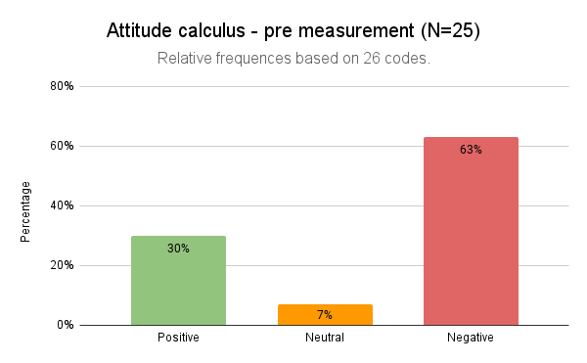

- The purpose of this open-ended question - "What do you think about maths?" - was to capture the attitude of participants.
- The graph shows most answers were coded as negative (63%). The remainder of the responses are coded positive (30%) and a small number are neutral (7%).
- Reporting: "Most children who participated in the impact measurement (N=25) had a negative attitude towards maths: 63% of all answers to the question "What do you think about maths?" was negative. The rest of the answers were positive (30%) or neutral (7%). The audience activity thus reached the right target group (children with negative attitudes towards maths)."
Be aware that the calculated percentages in the previous steps refer to the number of codes, which does not always equal the number of participants.
For example, in the exercise file, the number of codes does not equal the number of participants, because some statements were given multiple codes (positive and negative). Therefore, the report states: "63% of all responses were negative" and not "63% of all participants expressed themselves negatively". This is also the reason for the sentence "Relative frequency based on 26 codes" in the graph.

Sample size
- The more people participated in your impact measurement, the more reliable the results will be. For an impact measurement, you can say that the data is reasonably reliable from 50 participants onwards.
- When sharing your results, always mention the sample (N) and avoid drawing sweeping conclusions if your sample is small. For example, say "70% of impact measurement participants (N=20) reported having learnt something new," rather than "70% of all participants learnt something new.").

Making comparisons
When you have conducted multiple impact measurements or used a pre- and post-measurement, you can compare the results of these measurements. For qualitative data, you can do this by comparing how often specific codes occur in different measurements. We use the graphs from the exercise file to give an example of this:
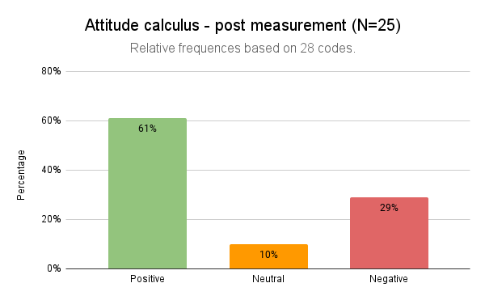

- Children's attitudes changed after the audience activity: compared to the pre-measurements, answers are more often positive and less often negative. There is little difference in the number of neutral responses.
- Reporting: "The attitudes of the children who participated in the impact measurement (N=25) changed after the audience activity: compared to the pre-measurement, the children more often answered positively and less often negatively to the question "What do you think about maths?" These results possibly indicate the audience activity made some of the children think more positively about maths."
- Given the small sample, it is not necessary in this example to also report the percentage decrease and increase. For example, with a larger sample, you could report, "The number of positive responses to the question "What do you think about maths?" increased by 31% after following the lesson set. Before the lesson set, 30% of responses were positive, after the lesson set this number increased to 61%."

3.2.3 Interviews
In this example, we will show you how to analyse data from an interview. We will use thematic analysis, with a combination of inductive and deductive coding.
As an example, we use a fictitious impact measurement of a short documentary on environmental pollution in the clothing industry. To identify whether the documentary mainly had an impact on participants' knowledge, attitudes and/or behaviour, these three main themes are devised as codes (deductive). The themes and issues raised in the interviews are identified after reading through and analysing the interviews (inductive).
Preparation
It is a good idea to save a copy of the original dataset (the transcribed interviews) first. Click File and then Create Copy. You can call this copy "Raw data", for example.
Before you start coding, take a moment to reflect on your research question. What was the purpose of these interviews and what research question do you want to answer? For example, if you conducted interviews to find out what people thought of your audience activity, it makes sense to look at feelings, opinions and experiences. This will help you realise what to look out for when reading the interviews.

Define codes
As support for the next few steps, you can use this template. Always make a copy of the template before making adjustments.
Start at tab 1. Themes. If you have not determined in advance which codes you will use (inductive coding), you can determine which codes you will use in two steps:
- Read through the interviews and under the column Themes step 1, keep track of all the themes that recur in the text. The themes may be broad in this step.
- Read through the themes from step 1 and decide whether you can merge themes. In general, it's a good idea to delimit codes as much as possible and make sure they do not overlap. The themes you are left with after this step are noted under Themes step 2. These are the codes you will use to analyse the data.
If you had thought of codes beforehand, write them down in Themes step 1. Then read through all the interviews and note any themes that might also be relevant as codes in the same column. After this, follow step 2 as described above.
In the example, the codes knowledge, attitude and behaviour were pre-conceived. After reading through the interviews, the codes were further refined and one code was added: awareness.

Themes step 1 | Themes step 2
Knowledge | Knowledge
Attitude | Attitude
Behaviour | Attitude: positive
Positive about the clothing industry | Attitude: negative
Negative about the clothing industry | Behaviour: intention
Became aware of the problem | Behaviour: no intention
Negative about the clothing industry
Wants to change their own behaviour
Does not want to change their own behaviour

Codebook
Once you have decided which codes you are going to use, you can write them down in a codebook. A codebook is a list of the codes you use and helps you keep an overview while coding. It makes it clear to yourself and others what codes there are and what those codes mean.
In tab 2. Codebook you can easily create this codebook. In the left-hand column, you can write or paste all codes from tab 1. You then give each code a definition and an example from the data. The codebook is also kept up to date during the analysis - this allows you to define and delimit the codes even better. If new codes emerge during the analysis, you can add them to the codebook.
The codebook from the example looks as follows (pnt stands for participant):
Name code | Colour | Definition | Examples
Knowledge |  | Pnt indicates they have learned something. | “Definitely useful, I learned a lot about the industry.”
Awareness |  | Pnt indicates they became aware of the problem | “The problem is much bigger than I thought.”
Attitude: pos |  | Pnt expresses themselves positively about the fashion industry. | “It is pure luxury that we can find something new to buy every week, and I secretly love it.”
Attitude: neg |  | Pnt expresses themselves negatively about the fashion industry. | “I was shocked by the young employees. It’s in the back of your mind, but now you’re really being confronted with it.”
Behaviour: intention |  | Pnt has the intention to change their behaviour. | “I think I will shop with more awareness now. It really made an impression.”
Behaviour: no intention |  | Pnt has no intention to change their behaviour. | “My own choices change very little, and sustainable clothing is very expensive.”

In the codebook, you also give each code a colour. You will use this colour later to mark the text in the interviews. Make sure the colours you use are easily distinguishable from each other.
Coding
Using the codebook as a reminder, you can now start coding the interviews. You do this by reading the transcribed interviews sentence-by-sentence for each participant and then determining which code(s) the text belongs to.
Assigning codes is easiest by highlighting the text in question. In Google Sheets, you do this by first selecting the text and then clicking Marker colour, the symbol with the little brush, in the menu. Check in your codebook what colour the code is and choose this colour to highlight the text.
For example:
P: It does make you think, what all this shopping is doing to the world. That’s not something I usually think about (...) I do think I will shop a bit more consciously now. It really made an impression.
When you attribute code to a piece of text by highlighting it, it is useful to also keep track of this immediately in a summary. You can use tab 3. Analysis of the template. The tab is set up to allow you to indicate which codes you used for each participant (P1, P2). For example, if you have marked a piece of text for the first participant with the colour of the code Knowledge, you put a "1" in the Knowledge column of P1.
It may happen that a certain code occurs several times for one participant. For example, does the theme Knowledge occur twice for participant 1? Then put a "2" in the relevant column in the overview. This way you can easily visualise how often the codes occur per individual and across the entire dataset.
The completed analysis table then looks like this, for example:
PNT | Knowledge | Awareness | Attitude: pos | Attitude: neg | Behaviour: intention | Behaviour: no intention
P1 | 2 | 3 |  | 1 | 2
P2 |  | 1 |  | 1 | 2
P3 |  | 1 |  | 1 | 1 | 1
P4 | 1 | 3 |  | 1
P5 |  | 1 | 1 | 1
P6 |  | 2 |  | 1 | 1 | 1
P7 | 1 | 2 |  | 2 | 1
P8 |  | 1 | 1 |  |  | 1
P9 | 1 | 2 |  | 2 | 2
P10 |  | 1 | 1 | 1 |  | 1
Total | 6 | 17 | 3 | 11 | 9 | 4
% | 12% | 34% | 6% | 22% | 18% | 8%

Once all interviews have been coded, you can visualise how often each code appears in the dataset. You can do this by calculating frequencies and relative frequencies and then making a graph out of this. To do this, see the steps under "Open questions."

3.3 Interpretation and reporting
Study the graph you created in the previous steps with your research question in mind: what exactly did you want to measure with these interviews and what do the results say about this? We use the graph from the sample measurement to give an example of this:
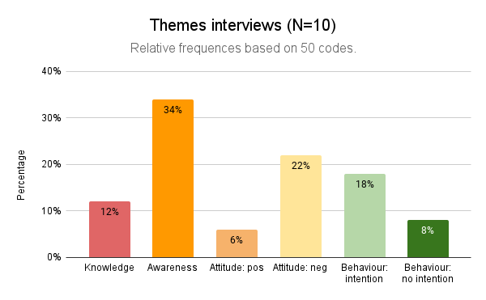

- The aim of the interviews was to discover the extent to which the documentary has influenced the knowledge, awareness, attitudes and behaviour of the visitors.
- The graph shows that most of the codes fall under awareness (34%). The analysis table on the previous page also shows that this theme occurred in every participant and in many participants more than once. Interpretation: this theme occurred most often, which may also show that the documentary had the greatest effect on participants' awareness compared to the other effects.
- After awareness, attitude is the most common: a total of 28% of the codes deal with attitudes of viewers. Only a small proportion (6%) of the codes are positive about the clothing industry and the vast majority (22%) are negative. The analysis table also shows that out of 10 participants, 9 participants expressed negative attitudes on the subject, compared to 3 participants who expressed positive attitudes. Interpretation: after the documentary, participants seem to have particularly negative attitudes towards the clothing industry.
- The theme behaviour occurs just slightly less often than attitude, in 26% of the codes. The majority of codes on behaviour shows an intention to change behaviour (18%), the other 8% do not. Interpretation: for a number of impact measurement participants (6 out of 10), the documentary may have contributed to a change in behaviour. However, four participants also indicated that they did not want to change certain behaviours. Thus, the impact on behaviour may not be as great as that on attitude or awareness.
- The theme knowledge was mentioned the least compared to the other four themes. Four out of 10 participants explicitly mentioned in their interview that they learned something. Interpretation: of all the effects, the documentary may have had the least effect on participants' knowledge.
Reporting
You can now summarise your interpretations into a number of conclusions for each theme and one overarching conclusion. For example, for the piece on awareness, you could say the following:
- "Out of all the impacts, the documentary possibly had the greatest effect on participants' awareness. This theme occurred among all impact measurement participants (N=10) and was mentioned most often: 34% of the 50 codes were about this topic."
  - It captures the imagination to also use one or two quotes with each conclusion, as with this piece on consciousness: "It does make you think, what all this shopping is doing to the world. I just don't think about that so much otherwise."
Be aware that the calculated percentages in the previous steps refer to the number of codes, not the number of participants. This is also the reason for the sentence "Relative frequency based on 50 codes" in the graph.

Sample size
- When sharing your results, always mention the sample (N) and avoid drawing sweeping conclusions if your sample is small. For example, say "70% of impact measurement participants (N=20) reported having learnt something new," rather than "70% of all participants learnt something new.").

Drawing comparisons
If you have conducted multiple impact measurements or used a pre- and post-measurement, you can compare the results of these measurements. See the section "Making comparisons" for the steps involved.

4. Setting improvement goals
Once you have interpreted and reported the results, you have a good idea of who you reached and what you achieved with your audience activity. In this section, we explain how to convert this knowledge into improvement goals: goals that will help you make your next audience activity sharper and more effective.
Roadmap
To set up improvement goals, you can use the following steps:
- Identify where the biggest opportunities for improvement lie.
Read through the results and interpretations from your report and determine the extent to which the goal of the audience activity was achieved. Also look at the questions your audience scored relatively low on and determine whether it is important to include this element in your improvement goals.
Example: the aim of your audience activity is to get people not close to science interested in history through a board game. After playing the game, you asked participants a number of questions, both about their science capital and their interest in history. Participants score high on interest after playing the game, so the activity achieved that goal. Participants also score high on science capital, which shows that the desired target group was not quite reached. Your improvement goal for a next edition: reach more people who are at a distance from science.
- Think about what you need to do to improve this.
If your improvement goal has to do with reaching certain target groups, you may first need to gain more knowledge about your target group, for example by learning what interests them and in what channels and ways you can best reach them. You can gain this kind of information by doing research, for example by interviewing people from your target audience.
When your improvement goal has to do with effects (changing knowledge, attitude and/or behaviour), it is important to identify why the desired effect was not achieved. Was the subject matter too difficult, not relevant or was the activity not stimulating enough? You may already be able to answer this by looking at other elements of your measurement, such as emotional memory or an open-ended question for comments. If using only the results from your measurement does not help you find out why your audience activity did not have the desired effect, you can also run a pilot among a small proportion of your target audience and ask them for feedback.
- Make a plan.
Once you have identified the areas in which your audience activity would benefit from improvement, you can draw up a plan. For this, you use the ideas and insights you gained in the previous step and convert them into concrete actions, such as: doing literature research, getting in touch with colleagues who have successfully carried out a similar activity, talking to your target group and organising a pilot.
- Implement changes
With the knowledge gained from the previous step, you can then make the necessary adjustments. It is okay to make changes step-by-step, in order to get a better idea of the elements that work and those that don't. To gain insight into this, though, you need to…
- Keep measuring
If you do not measure, you also cannot know whether the changes to your audience activity have had the desired effect. This is why it is important to carry out impact measurement for each edition of your audience activity. The advantage of ongoing measurement is that you can repeat the materials and measurement methods. In this way, measuring impact becomes an integral part of your scicom activity, making your scicom activity increasingly capable of reaching the set goals and target groups.

